GMF 10 Week 4 (April 27-May1, 2020) ANSWERS

Instructions: Please complete the following questions by researching online and watching video links. Please reach out to your teacher for help or guidance through email or Teams if needed. Live video tutorials are on Teams Wednesdays at 11am and will be recorded and posted on Teams to watch at your convenience.
Trigonometry
Watch the following videos and fill in the notes / answer the questions.
- Labelling sides
https://www.youtube.com/watch?v=1ALLrv2dQxc
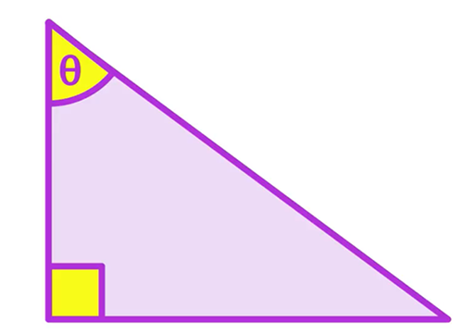 | What type of triangle is this? How do you know?  Right triangle – it has a 90° angle
This is the Greek letter called: ___theta______

It is used as a variable to represent: an angle
It is the ___longest___ side
It is always opposite the ____right angle____.
Opposite the angle we’re ___looking for_____
or
Opposite the angle we ___already know__
The one “_left over__”
The side next to the __right angle___ and the angle involved in the question
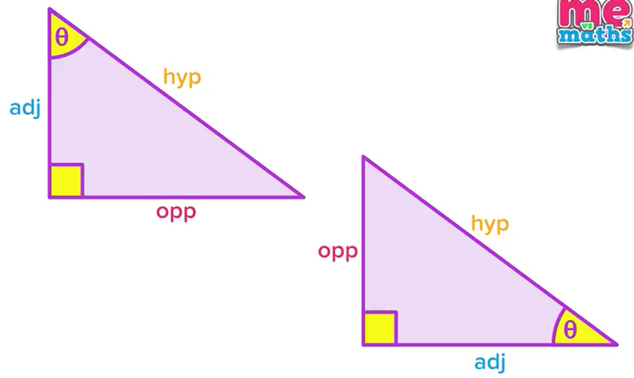 | Which side name stayed the same in both triangles?  the hypotenuse  Why did the “opp” and “adj” sides swap?  because the angle involved in the question changed
label the diagram with “hyp”, “opp” and “adj”
opp
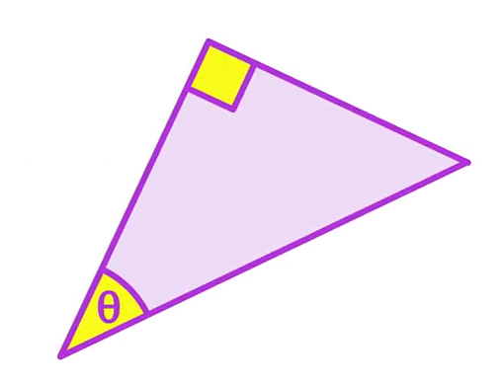
hyp
adj

Label the following triangles with “hyp”, “opp” and “adj” (in reference to the indicated angle)

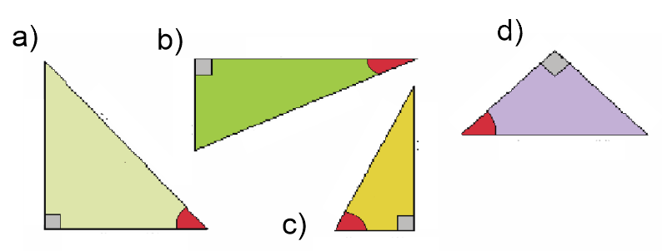
adj

opp

hyp

adj

opp

hyp

hyp

opp

adj

adj
opp
hyp
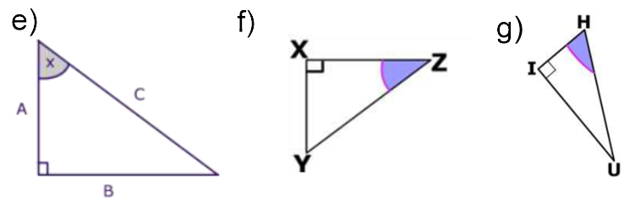
opp

hyp

adj

adj

hyp

opp

opp

adj

hyp

- Intro Trig ratios/identities/formulas
https://www.youtube.com/watch?v=tKAMM3kacbs

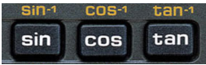 | Find these 3 buttons on your calculator.
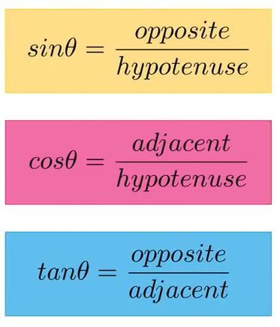 | These are the 3 Trig formulas.  What is the phrase used to remember the formulas?  SOH CAH TOA
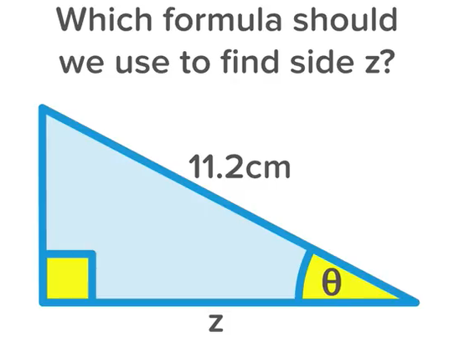  adj  hyp  opp | Label each side (hyp, opp, adj)  Which two sides of this triangle are “active”?  hyp and adj  Which formula uses both of those “active” sides?  cos$θ$=$\frac{adj}{hyp}$
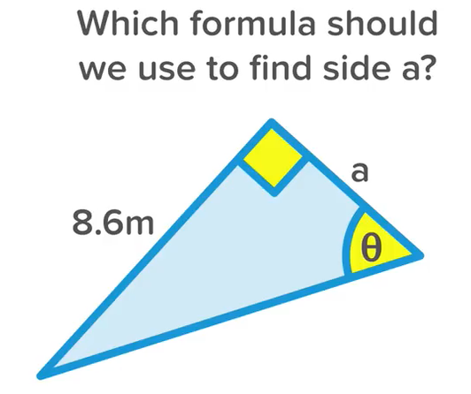  hyp  adj  opp | Label each side (hyp, opp, adj)  Which two sides of this triangle are “active”?  opp and adj  Which formula uses both of those “active” sides?  $\tan{θ}$=$\frac{opp}{adj}$

For the following questions, label each side (hyp, opp, adj) and decide which of the three trig formulas you would use, based on the “active” sides.
adj
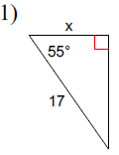  opp  opp  hyp | formula to be used:  cos$θ$=$\frac{adj}{hyp}$ | 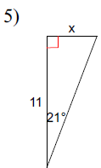  adj  hyp  opp | formula to be used:  $\tan{θ}$=$\frac{opp}{adj}$
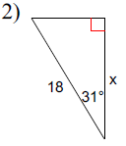  adj  hyp | formula to be used:  cos$θ$=$\frac{adj}{hyp}$ | 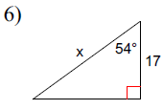  opp  opp  hyp | formula to be used:  adj  cos$θ$=$\frac{adj}{hyp}$
opp  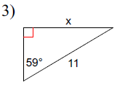  adj  hyp | formula to be used:  adj  $\sin{θ}$=$\frac{opp}{hyp}$ | 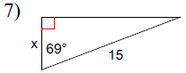  hyp | formula to be used:  cos$θ$=$\frac{adj}{hyp}$
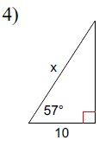  hyp  adj  opp | formula to be used:  cos$θ$=$\frac{adj}{hyp}$ | 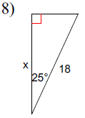  adj  hyp | formula to be used:  cos$θ$=$\frac{adj}{hyp}$
opp

- Finding missing sides

*** BEFORE YOU START THIS SECTION, AND USING THE SIN COS TAN BUTTONS ON YOUR CALCULATOR, YOU HAVE TO MAKE SURE YOUR CALCULATOR IS IN DEGREE MODE – look for a little D or DEG on your screen, if it shows R or RAD or G or GRAD, hit your “mode” button until it’s in degree mode, IF YOU AREN’T IN THE RIGHT MODE, YOUR ANSWERS WILL BE WRONG.

https://www.youtube.com/watch?v=E7y3ENOSGK4

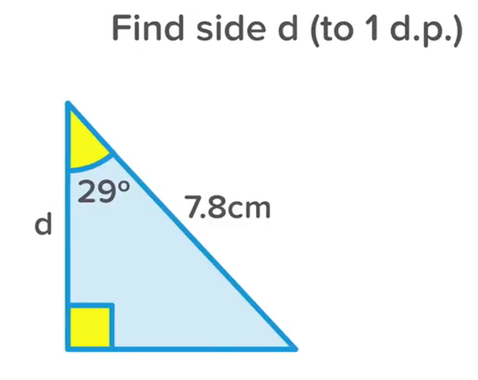  adj  opp  hyp | Example: Label the sides  Which two sides are “active”?  adj (because it has the variable “d” and hyp because it has a measurement.  formula:  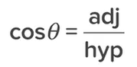  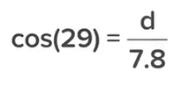  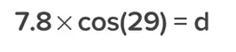  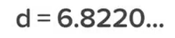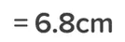
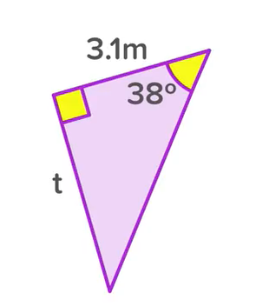  opp  adj  hyp | Label each side.  Explain why the correct formula is 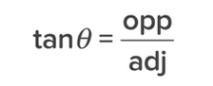  because the “active sides” are opp (t) and adj (3.1m)  Show the steps of how to get the missing side length “t”  $\tan{θ}$=$\frac{opp}{adj}$  $\tan{38}$=$\frac{t}{3.1}$  0.7813=$\frac{t}{3.1}$  t = 2.4 m
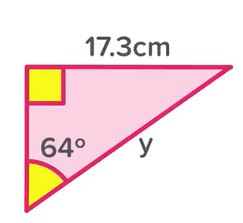  hyp  opp  adj | Label each side  Explain why the correct formula is  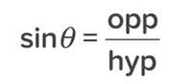  because the “active sides” are opp (17.3cm) and hyp (y)  Show the steps of how to get the missing side length “y”  $\sin{θ}$=$\frac{opp}{hyp}$  $\sin{64 }$= $\frac{17.3}{y}$  0.8988 = $\frac{17.3}{y}$ or y = $\frac{17.3}{\sin{64}}$  y = 19.2 cm  ***note, if you want to do the math a different way (that is still mathematically correct), you can do it your own way. The math shown in the video is a short-cut, short cuts are good, but sometimes confusing. Just make sure you can do it in a way that arrives at the correct answer
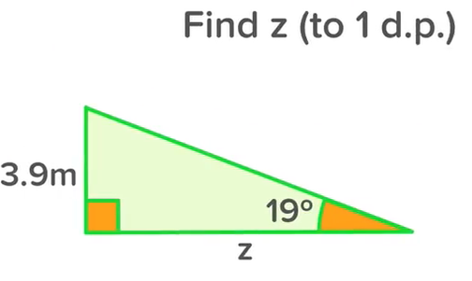  adj  opp  hyp | Label each side  Explain why the correct formula is  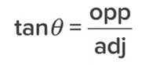  Show the steps of how to get the missing side length “z”  $\tan{θ}$=$\frac{opp}{adj}$  $\tan{19}$=$\frac{3.9}{z}$  0.3443=$\frac{3.9}{z}$ or z = $\frac{3.9}{\tan{19}}$  t = 11.3 m

Find the missing side lengths in the following triangles. For every question, label your sides and write your formula. Round answers to one decimal place.
adj  opp  hyp | cos$θ$=$\frac{adj}{hyp}$  $$\cos{55}=\frac{x}{17}$$  $$0.5735=\frac{x}{17}$$  (if you are going to round off like I did, make sure you use at least 4 decimals)  x = 9.8 | adj  hyp  opp | $\tan{θ}$=$\frac{opp}{adj}$  $\tan{21}$=$\frac{x}{11}$  $0.3839$=$\frac{x}{11}$  x = 4.2
opp  adj  hyp | cos$θ$=$\frac{adj}{hyp}$  cos$31$=$\frac{x}{18}$  0.8572=$\frac{x}{18}$  x = 15.4 | adj  opp  hyp | cos$θ$=$\frac{adj}{hyp}$  cos$54$=$\frac{17}{x}$  x = $\frac{17}{\cos{54}}$  x = $\frac{17}{0.5879}$  x = 28.9
opp  adj  hyp | $\sin{θ}$=$\frac{opp}{hyp}$  $\sin{59}$=$\frac{x}{11}$  0.8572 =$\frac{x}{11}$  x = 9.4 | opp  adj  hyp | cos$θ$=$\frac{adj}{hyp}$  $$\cos{69}=\frac{x}{15}$$  $$0.3584=\frac{x}{15}$$  x = 5.4
hyp  adj  opp | cos$θ$=$\frac{adj}{hyp}$  cos$57$=$\frac{10}{x}$  x = $\frac{10}{\cos{57}}$  x = $\frac{10}{0.5446}$  x = 18.4 | adj  hyp | cos$θ$=$\frac{adj}{hyp}$  $$\cos{25}=\frac{x}{18}$$  $$0.9063=\frac{x}{18}$$  x = 16.3
opp

I’m going to post the answers (without the work) below so you know if you did the questions correctly or not.
