GMF 10 Week 5 (May 4-8, 2020) ANSWERS

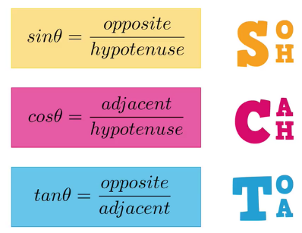
Instructions: Please complete the following questions by researching online and watching video links. Please reach out to your teacher for help or guidance through email or Teams if needed. Live video tutorials are on Teams Wednesdays at 11am and will be recorded and posted on Teams to watch at your convenience.
Trigonometry
Watch the following videos and fill in the notes / answer the questions.
*** MAKE SURE YOUR CALCULATOR IS IN DEGREE MODE

Finding missing angles: https://www.youtube.com/watch?v=ZDXc41r-jro
Inverse trig functions  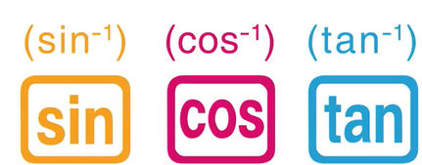 | How do you access these on your calculator?  Most calculators you need to press “shift” or “2ndF” and the regular sin cos tan buttons
adj  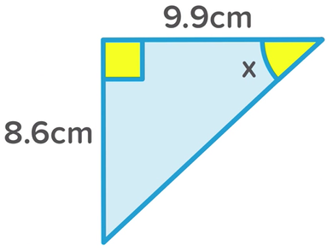  hyp  opp | 1. Label sides (opp, adj, hyp)  2. Choose the correct formula based on the “active” sides  tan – because it uses opp (8.6cm) and adj (9.9cm)  3. Fill in the formula:  $$\tan{θ}=\frac{opp}{adj}$$  $$\tan{x}=\frac{8.6}{9.9}$$  You can do it the same way the video does, but usually I do it like you see below. You decide which makes more sense to you.  $\tan{x}=0.8687$…  keep all of the decimals in the calculator and then hit your shift or 2ndF and the tan button, =  x = 41.0°
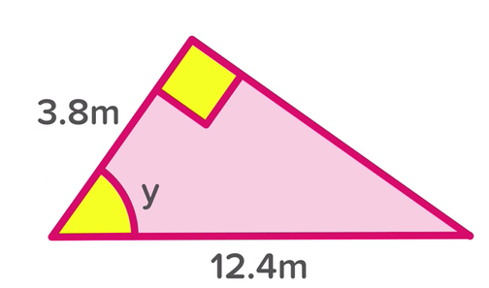  hyp  adj | 1. Label sides (opp, adj, hyp)  opp  2. Choose the correct formula based on the “active” sides  cos – because it uses hyp (12.4m) and adj (3.8m)  3. Fill in the formula:  $$\cos{θ}=\frac{adj}{hyp}$$  $$\cos{y}=\frac{3.8}{12.4}$$  $$\cos{y}=0.3065$$  $$y =72.2°$$

Find the missing angles in the following triangles. For every question, label your sides and write your formula. Round answers to the nearest degree.
hyp  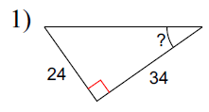  adj  opp | $$\tan{θ}=\frac{opp}{adj}$$  $$\tan{θ}=\frac{24}{34}$$  $$\tan{θ}=0.7059$$  $θ$ = 35° | opp  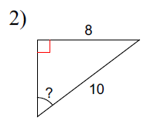  adj  hyp | $$\sin{θ= }\frac{opp}{hyp}$$  $$\sin{θ= }\frac{8}{10}$$  $$\sin{θ= }0.8$$  $θ$ = 53°
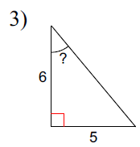  opp  adj  hyp | $$\tan{θ}=\frac{opp}{adj}$$  $$\tan{θ}=\frac{5}{6}$$  $$\tan{θ}=0.8333$$  $θ$ = 40° | adj  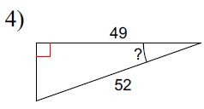  opp  hyp | $$\cos{θ}=\frac{adj}{hyp}$$  $$\cos{θ}=\frac{49}{52}$$  $$\cos{θ}=0.9423$$  $$θ =20°$$
adj  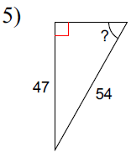  hyp  opp | $$\sin{θ= }\frac{opp}{hyp}$$  $$\sin{θ= }\frac{47}{54}$$  $$\sin{θ= }0.8704$$  $θ$ = 61° | adj  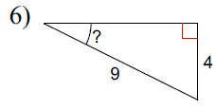  opp  hyp | $$\sin{θ= }\frac{opp}{hyp}$$  $$\sin{θ= }\frac{4}{9}$$  $$\sin{θ= }0.4444$$  $θ$ = 26°
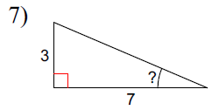  adj  opp  hyp | $$\tan{θ}=\frac{opp}{adj}$$  $$\tan{θ}=\frac{3}{7}$$  $$\tan{θ}=0.4286$$  $θ$ = 23° | adj  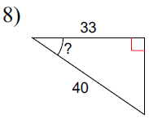  hyp  opp | $$\cos{θ}=\frac{adj}{hyp}$$  $$\cos{θ}=\frac{33}{40}$$  $$\cos{θ}=0.825$$  $$θ =34°$$

I’m going to post the answers (without the work) below so you know if you did the questions correctly or not.
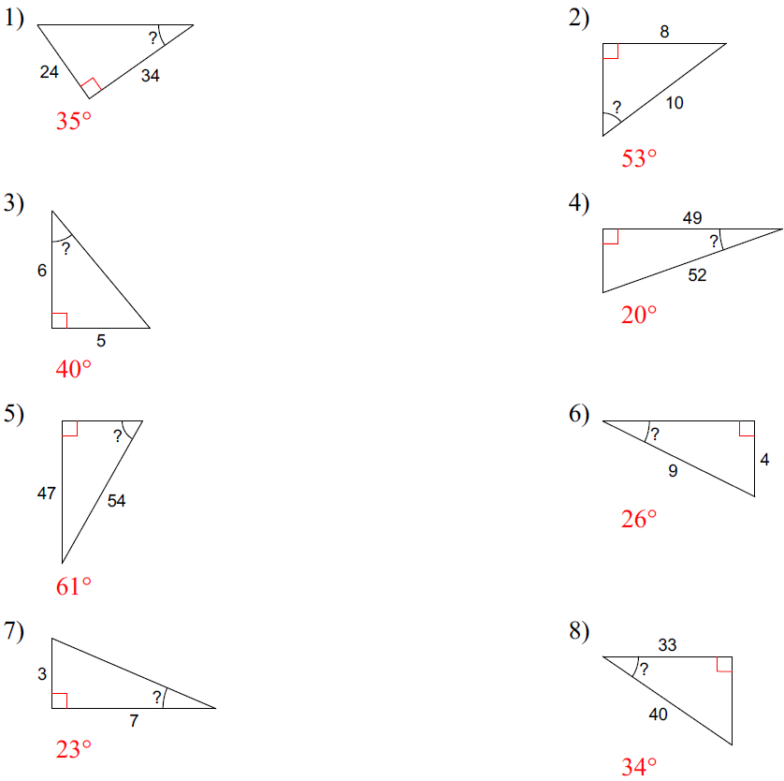
Combined Practice: https://www.youtube.com/watch?v=CJ6PiXct-ls
Fill in the comparison table from the video
used in right angle triangles | used in right angle triangles
can find a missing side using another side and an angle | can find a missing side using both the other sides
can find a missing angle using two sides | can not be used to find an angle

Use the video to help you find the answers. The video doesn’t show the formulas or most of the work, but I’d like you to in the space below.
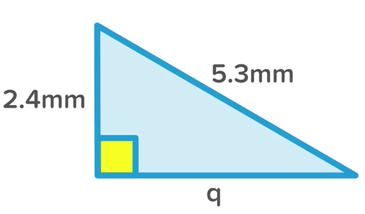 | 1. Explain in your own words how to determine whether you use SOH CAH TOA or Pythagorean Theorem to find “q”.  it’s a right angle triangle that has two of the sides given so we can use Pythag to find the missing side  2. Show the formula, the work, and the answer  $$a^{2}+ b^{2}= c^{2}$$  $${2.4}^{2}+ b^{2}= {5.3}^{2}$$  $$5.76+ b^{2}= 28.09$$  $$b^{2}= 22.33$$  $$b= \sqrt{23.33}$$  $$b=4.7 mm$$
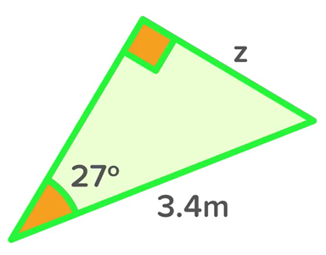 | 1. Explain in your own words how to determine whether you use SOH CAH TOA or Pythagorean Theorem to find “z”.  it’s a right angle triangle with a given side and angle so we use SOH CAH TOA  2. Show the formula, the work, and the answer  $$\sin{θ= }\frac{opp}{hyp}$$  $$\sin{27= }\frac{z}{3.4}$$  $$0.4540= \frac{z}{3.4}$$  $$z=1.5 m$$
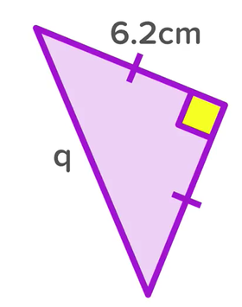 | 1. Explain in your own words why you can use both SOH CAH TOA and Pythagorean Theorem to find “q”.  Isosceles triangles have two equal sides, so because you know two sides, you can use Pythag to find the third side.  You can also use SOH CAH TOA because you also have a side and an angle. The angle is less obvious, but since one angle is 90° and the other two are equal and all 3 add to 180° then the angles must each be 45°.  2. Show the formula, the work, and the answer using Pythagorean Theorem.  $$a^{2}+ b^{2}= c^{2}$$  $${6.2}^{2}+ {6.2}^{2}= c^{2}$$  $$38.44+ 38.44= c^{2}$$  $$c^{2}= 76.88$$  $$c= \sqrt{76.88}$$  $$c=8.8 cm$$  3. Show the formula, the work, and the answer using SOH CAH TOA.  $$\cos{θ}=\frac{adj}{hyp}$$  $$\cos{45}=\frac{6.2}{q}$$  $$0.7071=\frac{6.2}{q}$$  $$q=8.8 cm$$
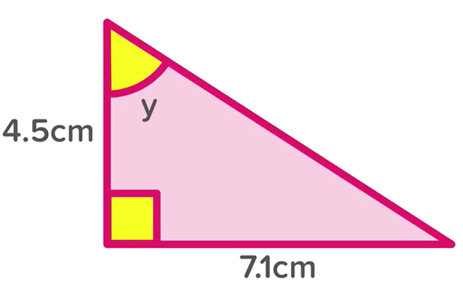 | 1. Explain in your own words how to determine whether you use SOH CAH TOA or Pythagorean Theorem to find “y”.  You use SOH CAH TOA, Pythag doesn’t deal with angles.  2. Show the formula, the work, and the answer  $$\tan{θ}=\frac{opp}{adj}$$  $$\tan{θ}=\frac{7.1}{4.5}$$  $$\tan{θ}=1.5777$$  $θ$ = 57.6°
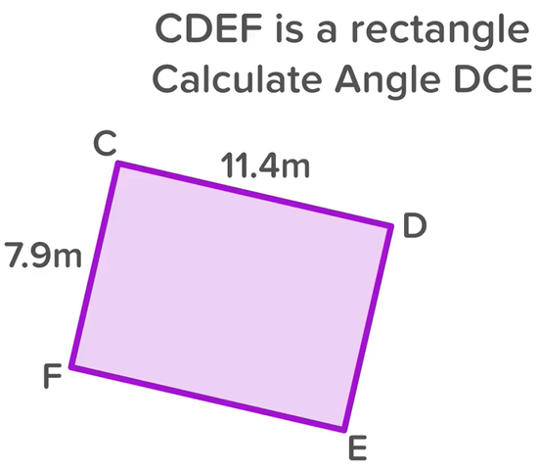  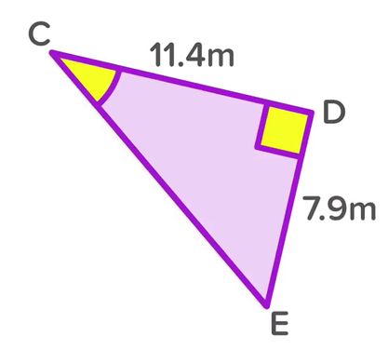 | 1. Explain in your own words how and why the person in the video creates the second image from the first image, in order to solve the problem of finding angle DCE.  Angle DCE is the angle you get when you draw a diagonal between C and E, it then becomes a right angle triangle. Since the original was a rectangle, CF is the same as DE and therefore know two sides of this new triangle. To find the angle in the question, we need to use SOH CAH TOA.  2. Show the formula, the work, and the answer  $$\tan{θ}=\frac{opp}{adj}$$  $$\tan{θ}=\frac{7.9}{11.4}$$  $$\tan{θ}=0.6930$$  $θ$ = 34.7°
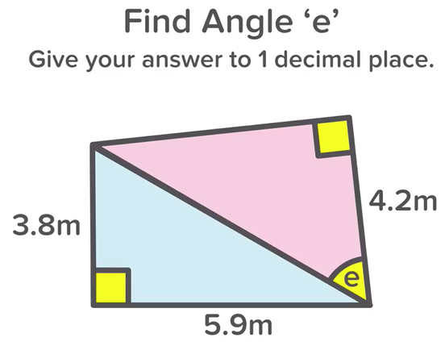 | Show and explain all the steps to answering the question, “find angle e”.  Angle ‘e’ is one angle in a right angle triangle, in which we know one of the sides (4.2m). In order to find the angle using SOH CAH TOA, we need at least two sides of that triangle. We can find the hypotenuse of the top purple triangle by using the information given for the bottom blue triangle. Both triangles share a hypotenuse. The blue triangle has two given sides, so we’ll use Pythag first to find it’s hypotenuse, and then use that number for the purple triangle.  Step 1:  $$a^{2}+ b^{2}= c^{2}$$  $${3.8}^{2}+ {5.9}^{2}= c^{2}$$  $$14.44+ 34.81= c^{2}$$  $$c^{2}=49.25$$  $$c= \sqrt{49.25}$$  $$c=7.0178 cm$$  Step 2:  $$\cos{θ}=\frac{adj}{hyp}$$  $$\cos{θ}=\frac{4.2}{7.0178}$$  $$\cos{θ}=0.5985$$  $$θ =53.2°$$

Practice questions:
- Find the side lengths or missing angles in the following triangles. For every question, write your formula and show your work. Round answers to one decimal place for side lengths and to the nearest degree for angles.
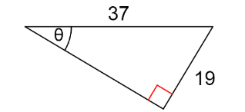 | $$\sin{θ= }\frac{opp}{hyp}$$  $$\sin{θ= }\frac{19}{37}$$  $$\sin{θ= }0.5135$$  $$θ=31°$$ | 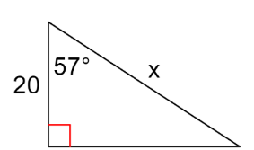 | $$\cos{θ}=\frac{adj}{hyp}$$  $$\cos{57}=\frac{20}{x}$$  $$0.5446=\frac{20}{x}$$  $$x=36.7$$
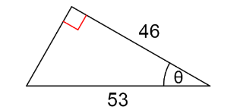 | $$\cos{θ}=\frac{adj}{hyp}$$  $$\cos{θ}=\frac{46}{53}$$  $$\cos{θ}=0.8679$$  $$θ=30°$$ | 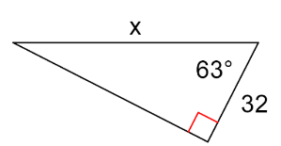 | $$\cos{θ}=\frac{adj}{hyp}$$  $$\cos{63}=\frac{32}{x}$$  $$0.4540=\frac{32}{x}$$  $$x=70$$
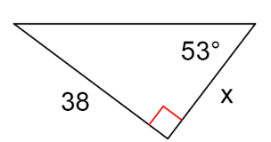 | $$\tan{θ}=\frac{opp}{adj}$$  $$\tan{53}=\frac{38}{x}$$  $$1.3270=\frac{38}{x}$$  $x$ = 28.6 | 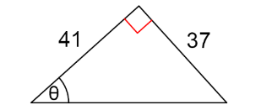 | $$\tan{θ}=\frac{opp}{adj}$$  $$\tan{θ}=\frac{37}{41}$$  $$\tan{θ}=0.9024$$  $θ$ = 42°

- Use your knowledge of angles, SOH CAH TOA and Pythagorean Theorem to find the missing sides and angles.
a: 14 cm | ∠ACB: 38°
b: 17.8 cm | ∠DCE: 52°
c: 9 cm | ∠CAD: 33°
e: 11.4 cm | ∠ADC: 57°
f: 21.1 cm | ∠CDE: 38°

