GMF 10 Week 6 (May 11-15, 2020)

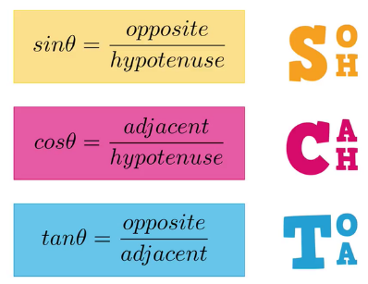
Instructions: Please complete the following questions by researching online and watching video links. Please reach out to your teacher for help or guidance through email or Teams if needed. Live video tutorials are on Teams Wednesdays at 11am and will be recorded and posted on Teams to watch at your convenience.
Angles of Elevation and Depression
Watch the following video (multiple times if needed) and fill in the notes / answer the questions.
*** MAKE SURE YOUR CALCULATOR IS IN DEGREE MODE
https://www.youtube.com/watch?v=7ONj6TKvi2g
Angle of Elevation vs. Angle of Depression  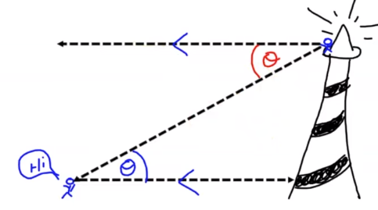 | angle of elevation is like looking ____ from horizontal  angle of depression is like looking _____ from horizontal  Explain why the two angles are equal.
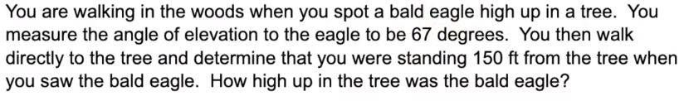  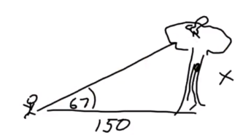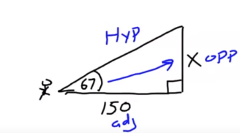 | Show the formula and the steps used to find the answer.
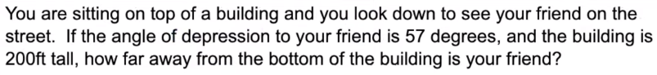  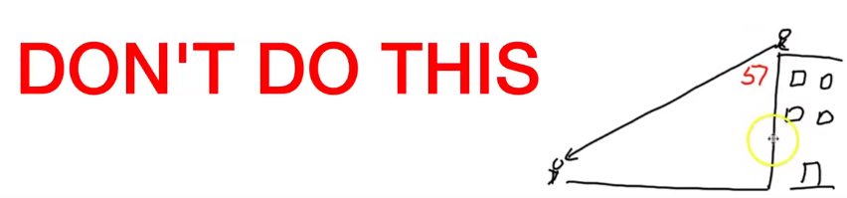  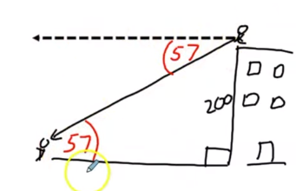  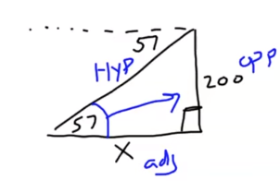 | Explain why the placement of the 57° in the first image is wrong.  Explain how you know that the angle of elevation is also 57°.  Show the formula and the steps to find the answer.
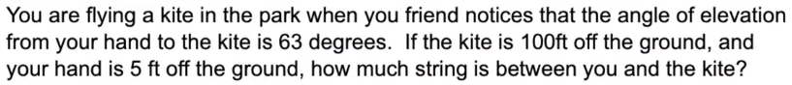  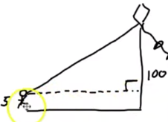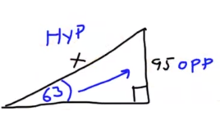 | Explain why the height used in the problem ends up only being 95ft.  Show the formula and the steps to find the answer.
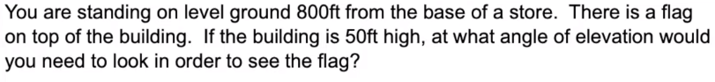  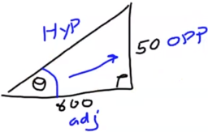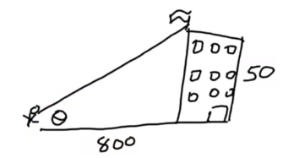 | Show the formula and the steps to find the answer.
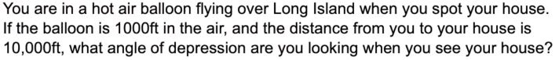  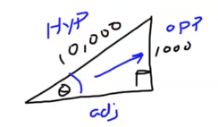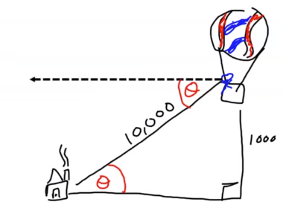 | Show the formula and the steps to find the answer.  What is the major tip given in the video to help you not mess up these questions?

Practice questions:
Best practice when completing word problems is to make a good diagram (always includes a right angle triangle for these questions), show your formula(s) and steps and then write a sentence for your answer (I’ll do #1 as an example).
- A slide has an angle of elevation of 25°. If the slide touches the ground 60 ft from the base of the ladder, how long is the slide?
Sketch  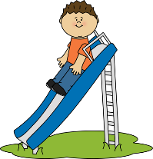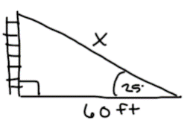 | Work  $$\cos{θ= \frac{adj}{hyp}}$$  $$\cos{25= \frac{60}{x}}$$  $$x{= \frac{60}{\cos{25}}}$$  $$x{= \frac{60}{0.9063}}$$  $$x{= 66.2 ft}$$ | Sentence  The slide is 66.2 ft long.

- A forest ranger is 150 ft from the base of a tree. The angle of elevation is 30°. How tall is the tree?
Sketch | Work | Sentence

- An escalator brings people to up or down to their destination more quickly. If the people are going up to a height of 48 ft and the angle of elevation is 15°, how long is the escalator?
Sketch | Work | Sentence

- A 150 ft tall lighthouse is at the top of a 200 ft cliff. The angle of depression between the top of the lighthouse and a boat off of the coast is 27°. What is the distance from the base of the lighthouse to the boat?
Sketch  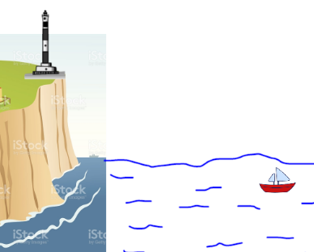 | Work | Sentence

- A plane flies at an altitude of 2 km. If the plane is 30 km from the airport, what is the angle of depression of the plane?
Sketch | Work | Sentence

- A wire reaches from the top of the pole to a stake in the ground. The stake is 10 feet from the foot of the pole. The wire makes an angle of 65° with the ground. Find the length of the wire to the nearest foot.
Sketch | Work | Sentence

- A boy who is flying a kite lets out 300 feet of string which makes an angle of 38° with the ground. Assuming that the string is straight, how high above the ground is the kite? Give your answer to the nearest foot.
Sketch | Work | Sentence

- A man standing 30 feet from the flagpole observes the angle of elevation of its top to be 48°. Find the height of the flagpole to the nearest tenth of a foot.
Sketch | Work | Sentence

- A Boy Scout on top of a 1,700-foot-tall mountain spots a campsite. If he measures the angle of depression at 35°, how far is the campsite from the foot of the mountain?
Sketch | Work | Sentence

- A soccer ball is placed 12 feet away from a goal post that measures 8 feet high. You kick the ball and it hits the crossbar at the top of the goal. What was the angle of elevation of your kick? Round to the nearest degree.
Sketch | Work | Sentence

- An airplane pilot observes the angle of depression of a point on a landing field to be 28°. If the plane’s altitude at this moment is 900 meters, find the distance from the pilot to the observed point on the landing field.
Sketch | Work | Sentence

- A tree that is 18 ft tall cast a shadow that is 20ft long. What is the angle of elevation of the sun?

Sketch | Work | Sentence

- Suppose your angle of elevation to the top of a water tower is 78°. If the water tower is 145 ft tall, how far are you standing from the water tower?

Sketch | Work | Sentence

- The angle of elevation from the control tower to an airplane is 49°. The airplane is flying at 5000 ft. How far away from the control tower is the plane?

Sketch | Work | Sentence

- A Boy Scout on top of a 1700-ft-tall mountain spots a campsite. If he measures the angle of depression at 35°, how far is the campsite from the foot of the mountain?

Sketch | Work | Sentence

- You are standing 10 ft away from a tree. The angle of elevation from your foot to the top of the tree is 65°. How tall is the tree?

Sketch | Work | Sentence

